Project Milestone-2
Dacharaju Vaishnavi-1309564

Data Visualization:
Box Plot:
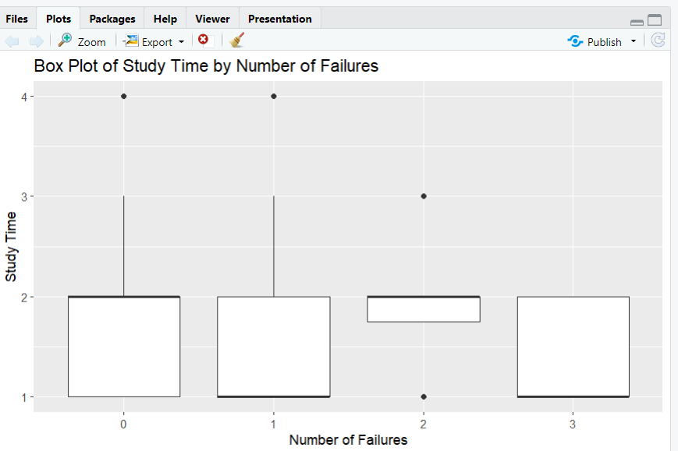

Histogram:
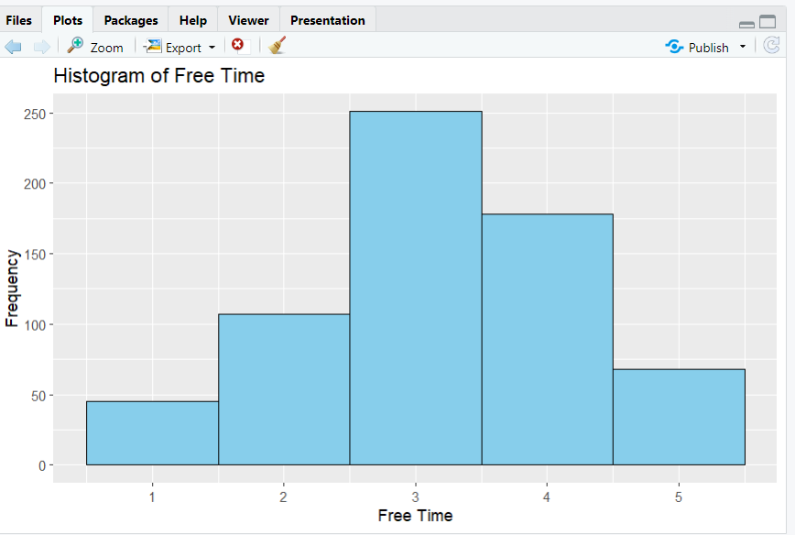
Scatter Plot:
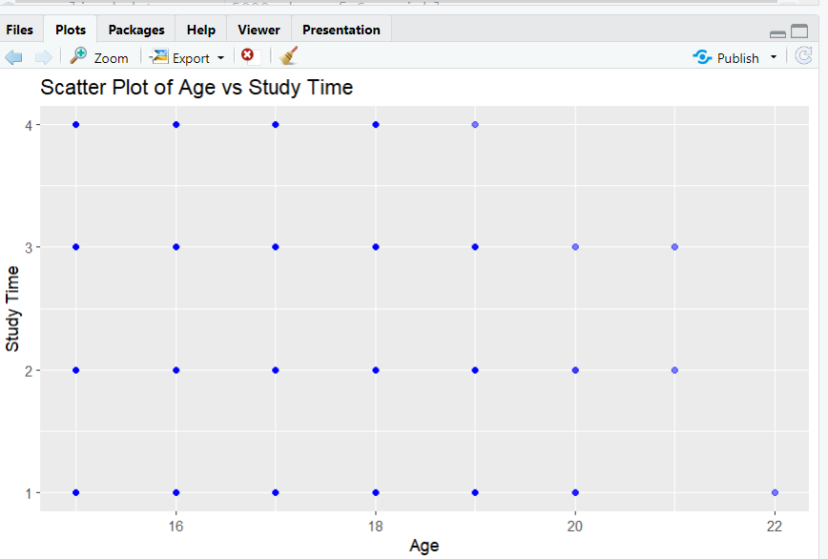
Bar Plot:
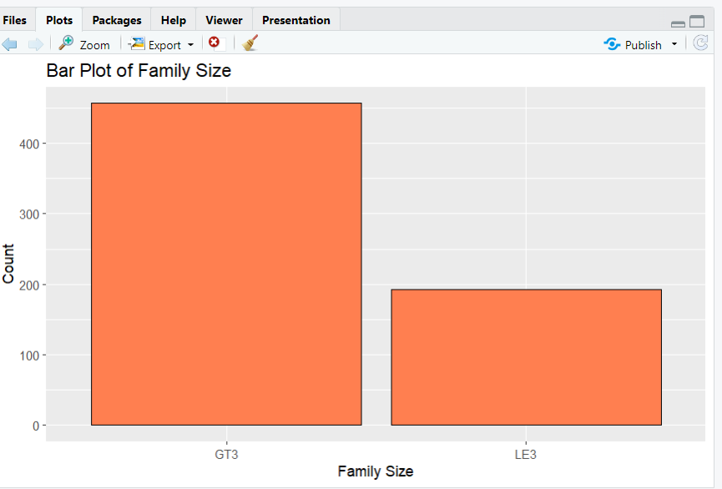

Density Distribution:
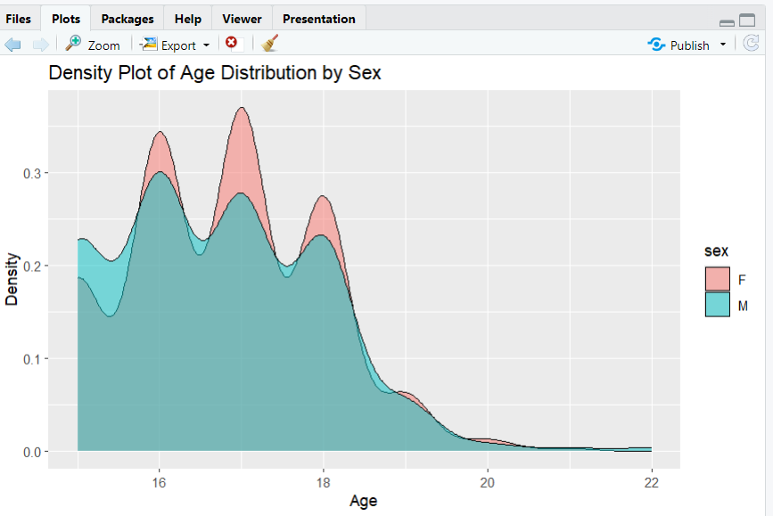

Apriori Analysis:
Apriori

Parameter specification:
confidence minval smax arem aval originalSupport maxtime support minlen maxlen target ext
0.7 0.1 1 none FALSE TRUE 5 0.1 1 10 rules TRUE

Algorithmic control:
filter tree heap memopt load sort verbose
0.1 TRUE TRUE FALSE TRUE 2 TRUE

Absolute minimum support count: 39

set item appearances ...[0 item(s)] done [0.00s].
set transactions ...[5 item(s), 390 transaction(s)] done [0.00s].
sorting and recoding items ... [5 item(s)] done [0.00s].
creating transaction tree ... done [0.00s].
checking subsets of size 1 2 done [0.00s].
writing ... [0 rule(s)] done [0.00s].
creating S4 object ... done [0.00s]

Confusion Matrix:
Confusion Matrix and Statistics

Reference
Prediction GT3 LE3
GT3 145 55
LE3 40 19

Accuracy : 0.6332
95% CI : (0.5713, 0.692)
No Information Rate : 0.7143
P-Value [Acc > NIR] : 0.9981

Kappa : 0.0432

Mcnemar's Test P-Value : 0.1509

Sensitivity : 0.7838
Specificity : 0.2568
Pos Pred Value : 0.7250
Neg Pred Value : 0.3220
Prevalence : 0.7143
Detection Rate : 0.5598
Detection Prevalence : 0.7722
Balanced Accuracy : 0.5203

'Positive' Class : GT3

Statistics:
Confusion Matrix and Statistics

Reference
Prediction GT3 LE3
GT3 156 56
LE3 29 18

Accuracy : 0.6718
95% CI : (0.611, 0.7287)
No Information Rate : 0.7143
P-Value [Acc > NIR] : 0.941615

Kappa : 0.0971

Mcnemar's Test P-Value : 0.004801

Sensitivity : 0.8432
Specificity : 0.2432
Pos Pred Value : 0.7358
Neg Pred Value : 0.3830
Prevalence : 0.7143
Detection Rate : 0.6023
Detection Prevalence : 0.8185
Balanced Accuracy : 0.5432

'Positive' Class : GT3

Corpus:

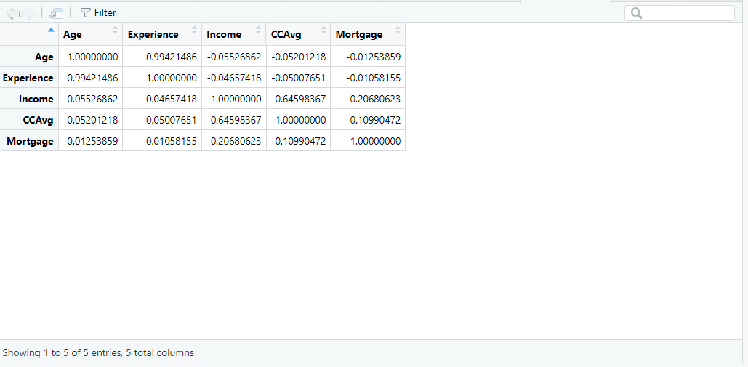

Top 10 terms in corpus:

The most frequent terms in the cleaned text data are identified and displayed. These terms give insights into common words related to students' family jobs.

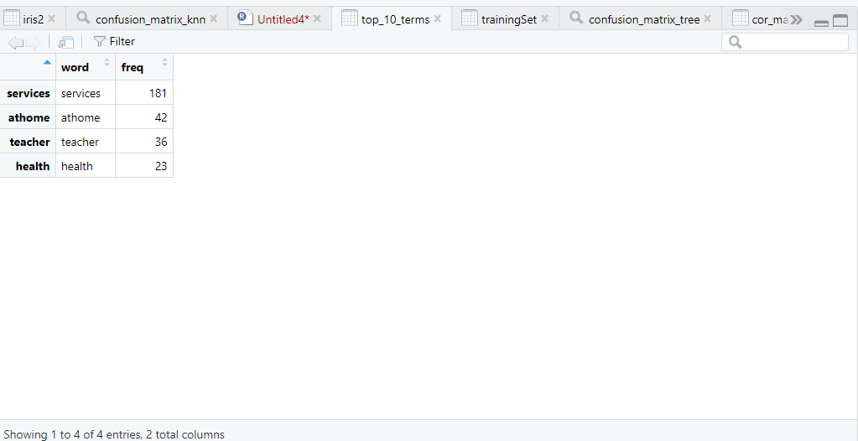

Word Cloud:
A word cloud visualization shows the top terms, with the size of each word indicating its frequency. This visual representation helps to quickly grasp the most common terms in the text data.
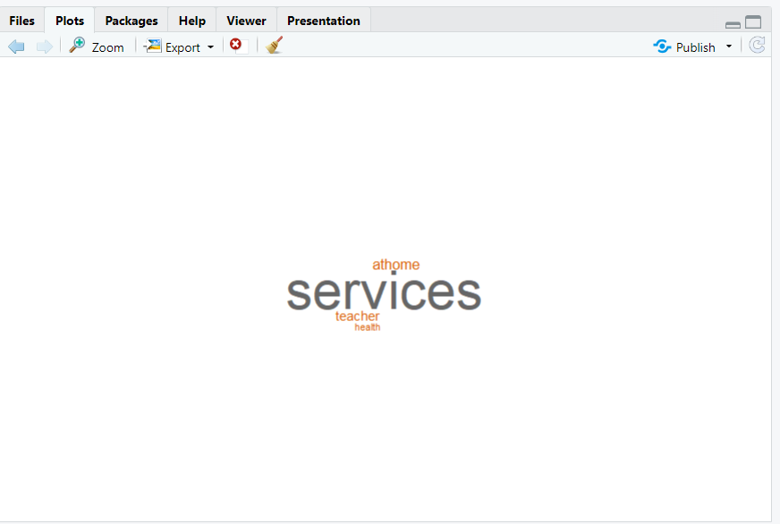

Clustering Analysis with Elbow Method:

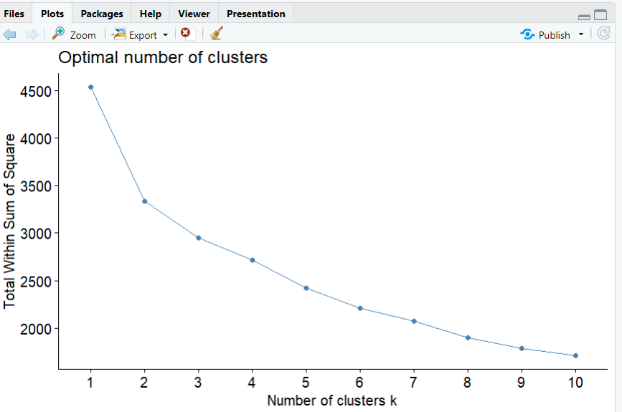

Visualization of clustering Results:

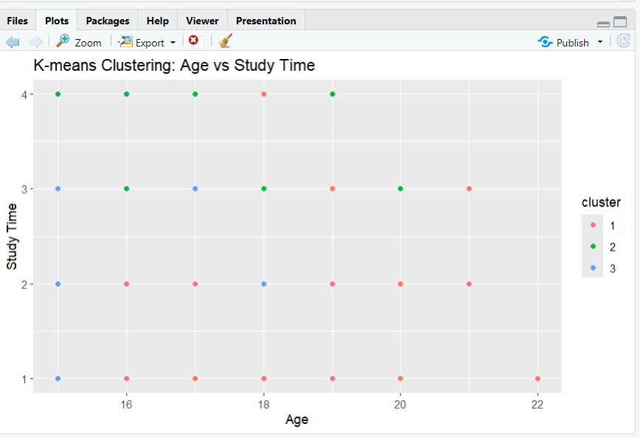

K- Mean Clustering:

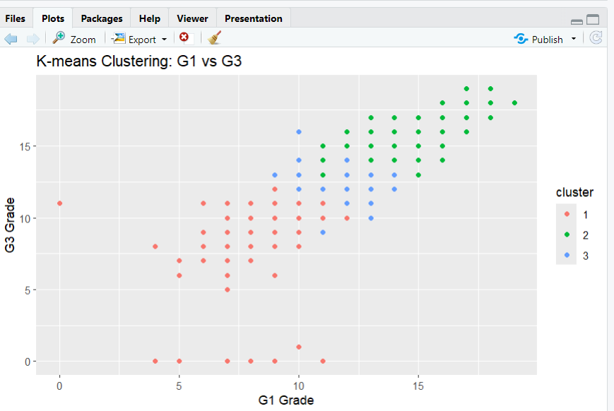

Summary of Clusters:

Length Class Mode
cluster 649 -none- numeric
centers 21 -none- numeric
totss 1 -none- numeric
withinss 3 -none- numeric
tot.withinss 1 -none- numeric
betweenss 1 -none- numeric
size 3 -none- numeric
iter 1 -none- numeric
ifault 1 -none- numeric

>

Top 10-word Frequency:

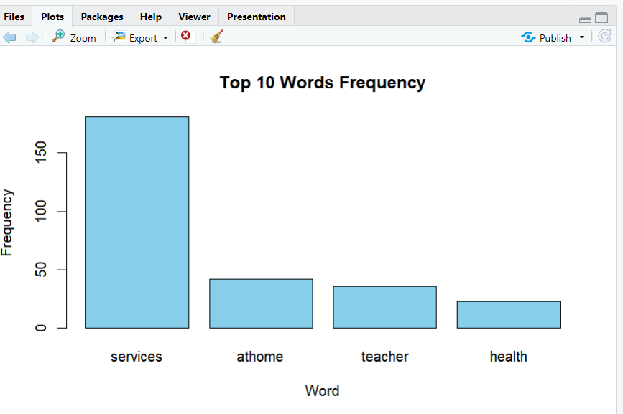

Comparison Results:
